BAHRIA UNIVERSITY KARACHI CAMPUS
Department of Computer Science

APPLIED PHYSICS

LAB EXPERIMENT # 1

Basic Instruments

OBJECTIVE:-

- Familiarized with the instruments of the lab

EQUIPMENT:-

- Oscilloscope
- Function Generator
- Multimeter
THEORY:-

Oscilloscope

The oscilloscope is a device that measures voltages. In the usual case, it displays the voltage as function of time. The heart of the oscilloscope is a cathode ray tube or (CRT).

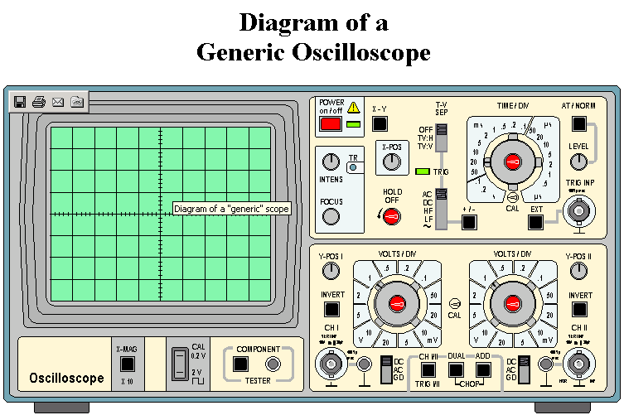
Sometimes you connect a signal to a scope, turn it on, and don't see anything! This can be another bit of a challenge. Some scopes have a control to try to make a reasonable set of guesses for the settings of the other controllers. This sometimes does not work, and many other scopes don't even have this capability. Here is a set of steps to try to find where a missing beam has gone.
- Make sure the scope is set up to display the beam you are trying to find.
- Set the trigger to automatic.
- Set the input signal to ground if possible.
- Set the Voltage Control to the least sensitive value possible. This is the largest value of the voltage per division.
- Set the Time base Control to a value approximately in the middle of the range of possible values.
- Adjust the controls for horizontal and vertical position of the beam. If all goes well you will eventually end up with a beam spread out across the screen horizontally and centered in the middle of the vertical axis.
As mentioned, usually the scope measures a voltage as a function of time, with the time being the horizontal axis. The Time base Control controls the scale of the time axis.
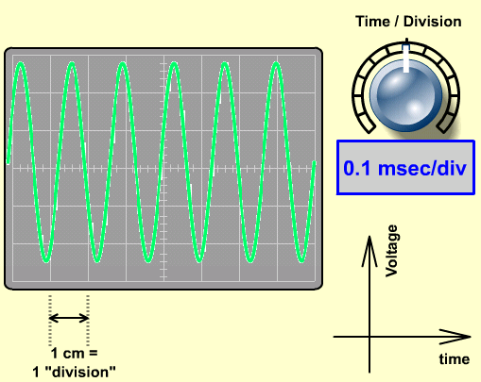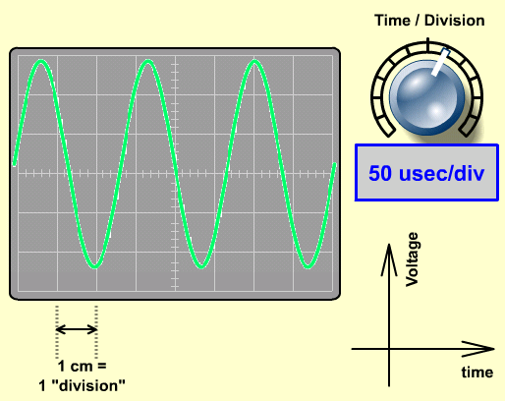

The effect of the Voltage Control on the vertical axis is similar to the effect of the Time Control on the horizontal one: lower values spread the voltage over a wider range of vertical values.

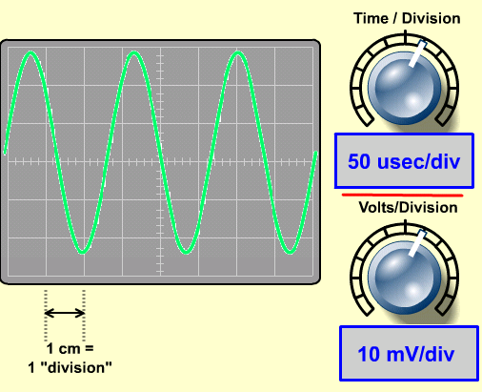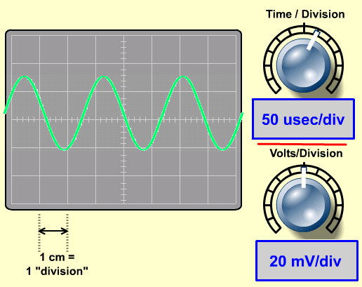

Function Generator

Function generators are signal sources which provide a specifiable voltage applied over a specifiable time, such as a sine wave" or triangle wave signal. These signals are used to control other apparatus to, for example, vary a magnetic field or act as a timing signal, i.e. clock (phase-sensitive detection experiments)
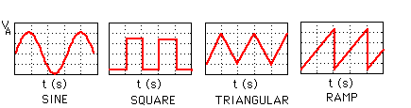

Different types of shapes generated by function generator

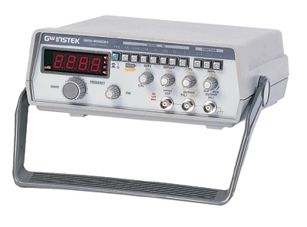

1. Power Switch. Turns power on and off.

2. Duty Cycle Switch. When engaged, enables operation of DUTYCYCLE control.

3. DC Offset Switch. When engaged, enables operation of the DC OFFSET control.

4. Range Switch. Selects output frequency range. Eight ranges from 1 Hz to 2 MHz. Switch indicate maximum frequency of range and is adjusted with COARSE FREQUENCY control to 0.1 times the maximum. For example, if the 200 kHz range is selected, the output frequency can be adjusted from 20 kHz to 200 kHz.

5. Function Switch. Selects sine, square or triangle waveform at OUTPUT jack.

6. Output Level Control. Controls the amplitude of the signal at the OUTPUT jack.

7. Start/Stop Switch. Enables adjustment of the starting and stopping sweep frequencies. The actual adjustment is performed by the SWEEP START and SWEEP STOP controls. START/STOP selection is enabled only when the SET/RUN switch is set to SET.

8. Sweep Time Control. In sweep mode, rotation determines amount of time to sweep from the start frequency to the stop frequency.

9. Fine Frequency Control. Vernier adjustment of the output frequency for ease of setting frequency.

10. Hz and KHz LED. Indicates whether the counter is reading in Hz or KHz.

Multimeter

A multimeter combines these functions and possibly some additional ones as well, into a single instrument.

An ammeter measures current.

A voltmeter measures the potential difference (voltage) between two points.

An ohmmeter measures resistance.

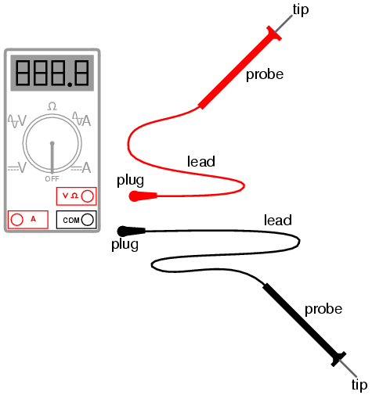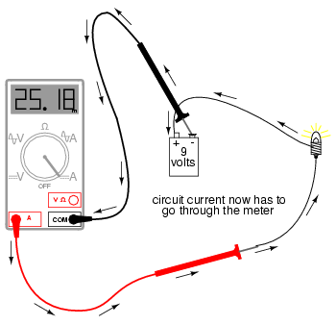

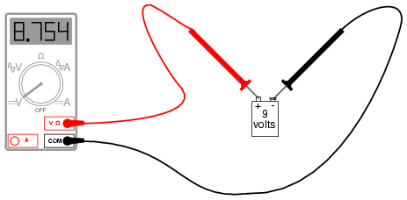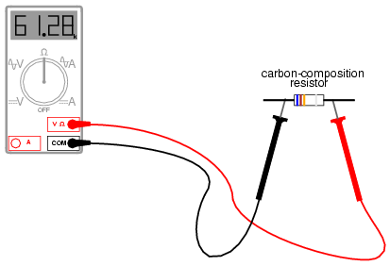

QUESTIONS:-

What is application of oscilloscope?

How many different types of signal can be generate by function generator also write there names?

Define digital multimeter (DMM)?

Teacher Signature: ________________________

Student Registration No.: ________________________

